Logic and Prolog – Practice Questions
- Consider the Green household. John and Sarah are married and have two children together: Mary and Tom. Mary later has a daughter named Ann. John and Tom are male, while Sarah, Mary, and Ann are female.
  - Based on these details, create a knowledge base in Prolog.
    - Define facts that represent parent-child relationships and individual genders.
    - Write general rules to deduce who someone's father is, who someone's mother is, who shares parents with whom (siblings, making sure a person cannot be their own sibling), and who qualifies as a grandparent to a grandchild.
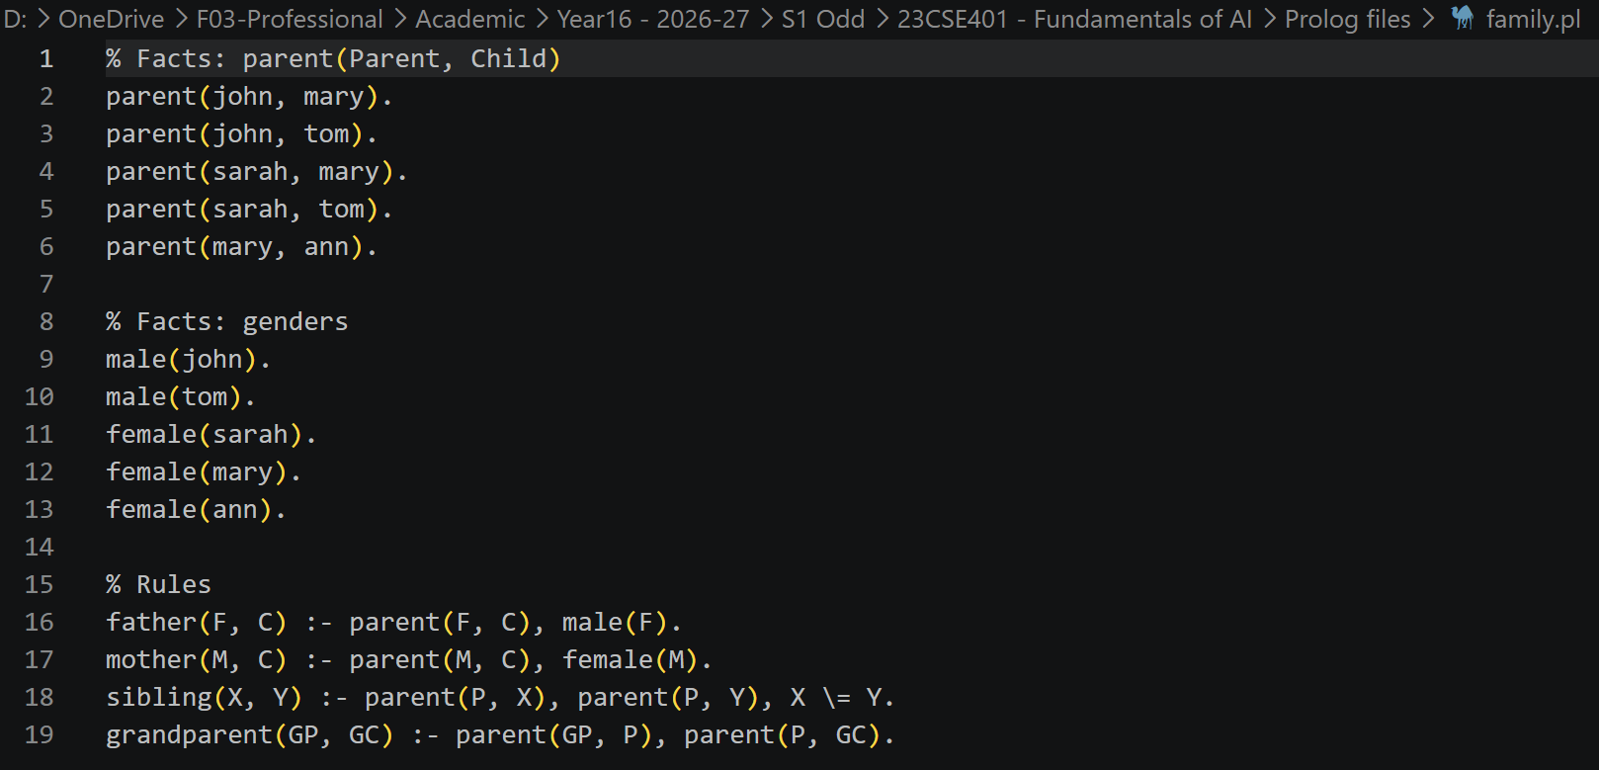
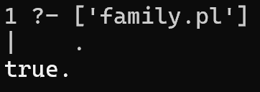
  - Answer the following queries:
    - ?- father(john, mary).
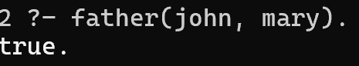
    - ?- mother(M, ann).
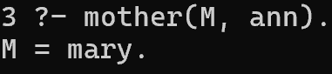
  - Write queries for the following:
    - List all children of John
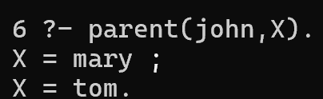
    - Find Mary's siblings.
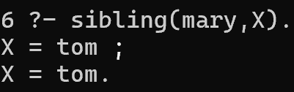
    - Identify who Ann's grandparents are.
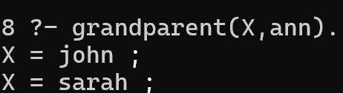
Alternates:
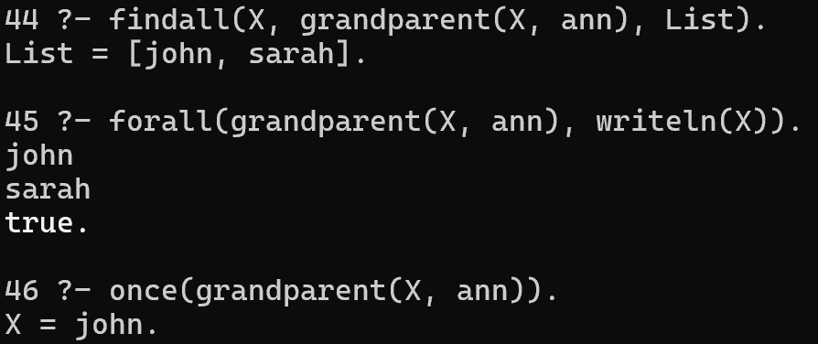
- A university campus cafe sells five items. For drinks, they serve espresso priced at $3 and latte priced at $5. For food, they offer croissants for $4, sandwiches for $8, and muffins for $3.
  - Build a Prolog program where each item is recorded with its name, category (either food or drink), and price
  - Add logic to determine whether an item is considered "affordable" given an arbitrary budget specified by the customer.
affordable(Item, Budget) :-
item(Item, _, Price), Price =< Budget.
  - Write a rule called meal_deal that combines exactly one food item and one beverage, computing the combined total cost.

meal_deal(Food, Drink, TotalCost) :-
item(Food, food, FoodPrice),
item(Drink, drink, DrinkPrice),
TotalCost is FoodPrice + DrinkPrice.
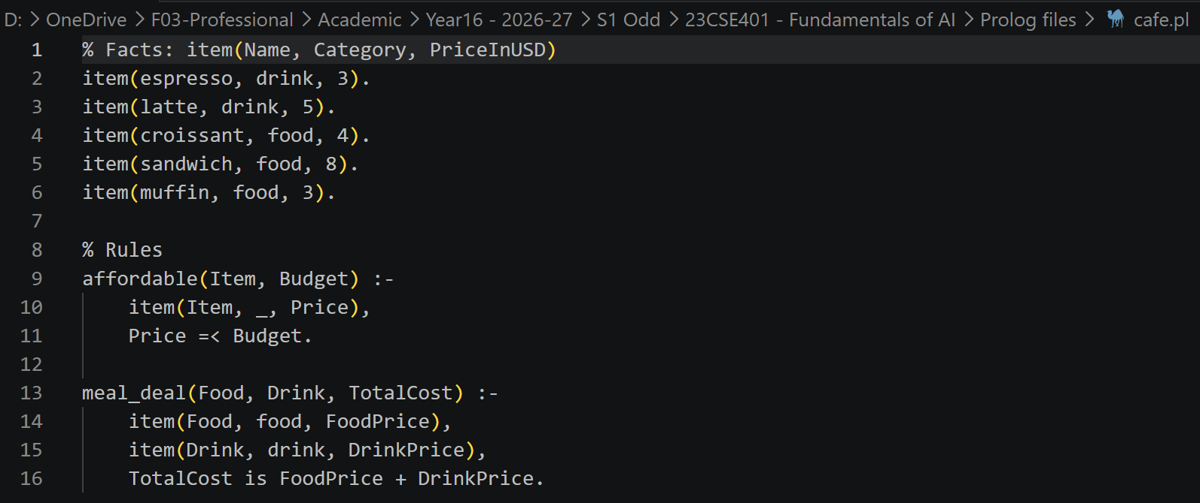
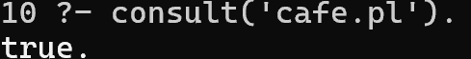
  - Query your system to find every possible food-and-drink combo a student can purchase for $10 or less.
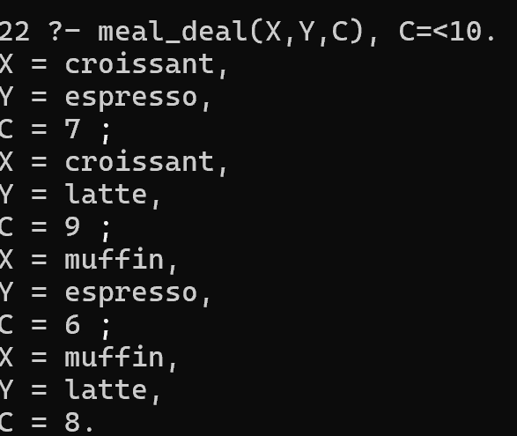
  - Write queries to answer the following:
    - List all food items
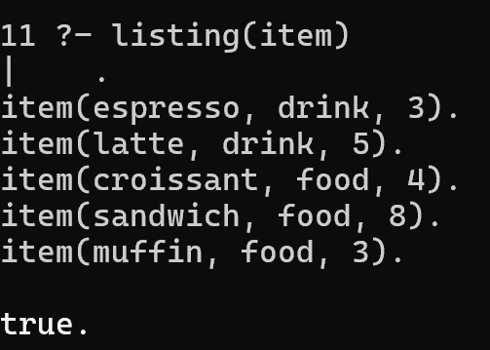
    - What can you buy with $4 or less?
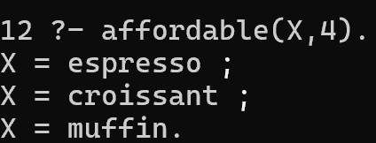

- The computer science department has strict sequencing for its core subjects. To enroll in CS102, a student must first complete CS101. CS201 requires both CS102 and Math101 as direct prerequisites. Finally, CS301 directly requires CS201 before a student can register.
  - Model these course requirements as Prolog facts.
  - Write a rule to check if a student can directly take a target course given a course they have completed.
  - Formulate a rule that checks whether a foundational course is required eventually (either directly or indirectly through a chain of prerequisite classes) to reach an advanced course.
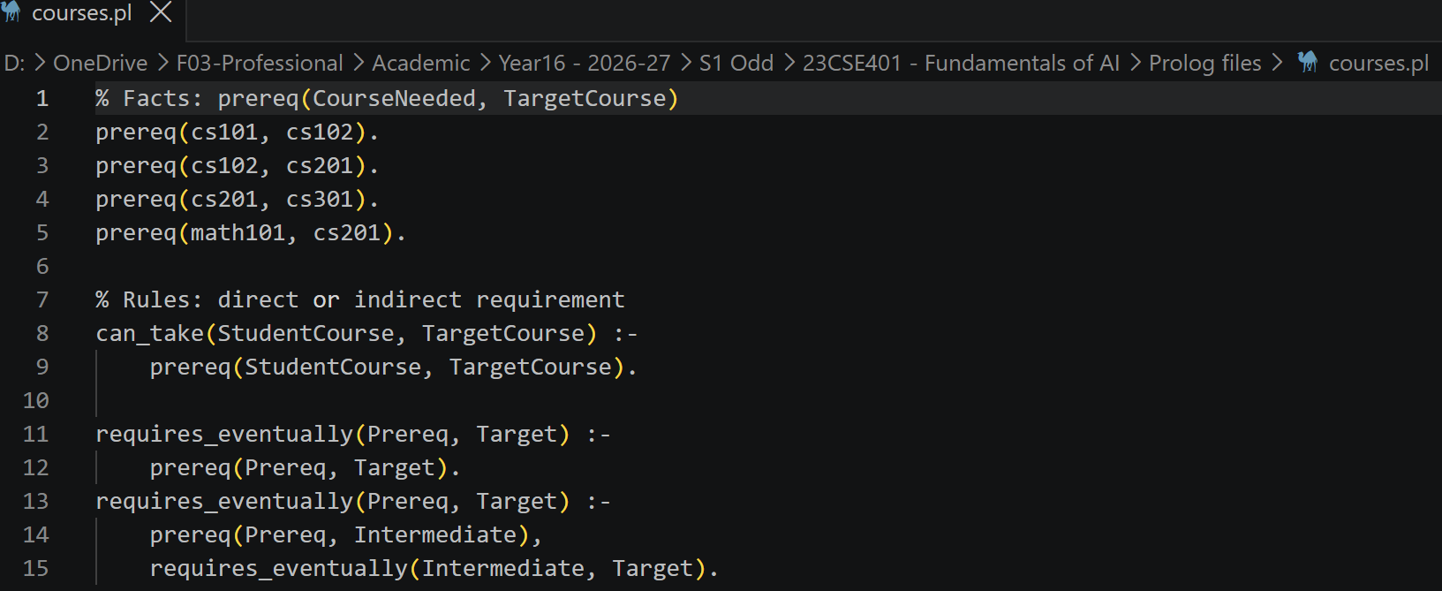
  - Query your knowledge base to list every prerequisite class a student must ultimately take before they can enroll in CS301.
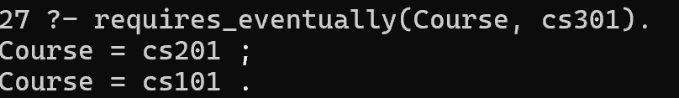
  - Write queries to identify the following:
    - What does cs201 directly require?
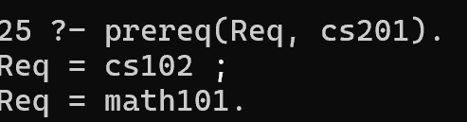
    - Can a student jump straight into cs301 from cs101 directly? No.
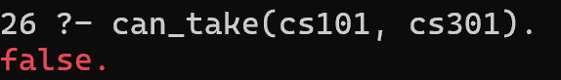
    - What are all the foundational courses needed eventually for cs301?

